*LAB # 12*

exception handling

# *OBJECTIVE:*

*To Study exception-handling (try,catch,throw,throws.finally) and creating your own exception subclasses*

LAB TASK

**Task # 01:**

*Refining Your Calculator: Your primary task for this lab is to restructure your calculator to handle exceptions. You can put the method in a try catch clause.*

**Code:**

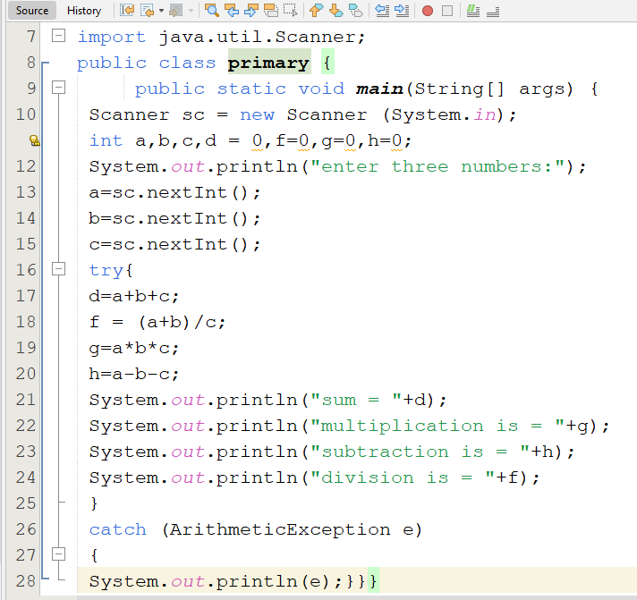

**Output**

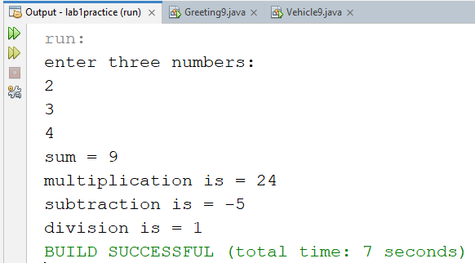

**Task # 02:**

*Write a program that accepts a test score, that is, a positive integer in the range 0 through 100 inclusive, and displays an equivalent letter grade: A (90), B (80–89), C (70–79), D (60–69), F (under 60). Throw an exception if the input is in the wrong format or if it is out of range, print an error message, and halt gracefully*

**Code:**

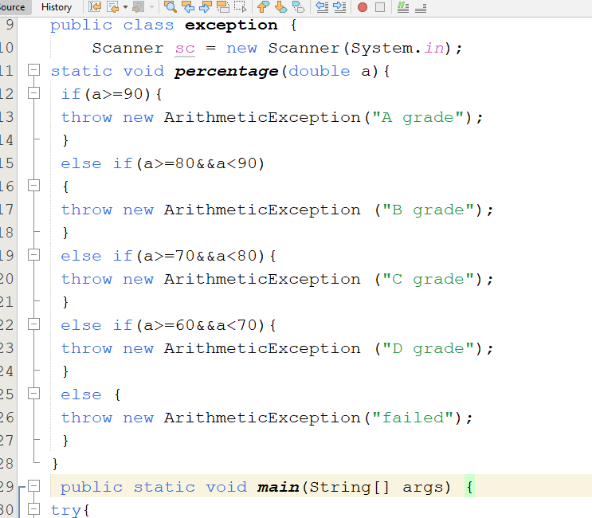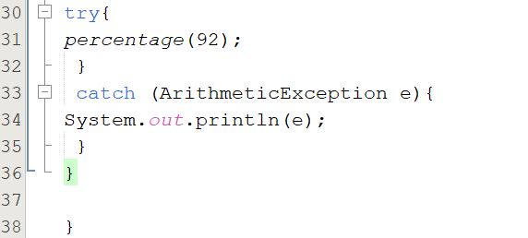

**Output:**

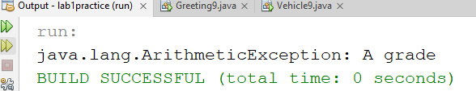

**Task # 03:**

*Write a program that meet the following requirements:*

*■ Creates an array with 100 randomly chosen integers.*

*■ Prompts the user to enter the index of the array, then displays the corresponding element value. If the specified index is out of bounds, display the message Out of Bounds*

**Code:**

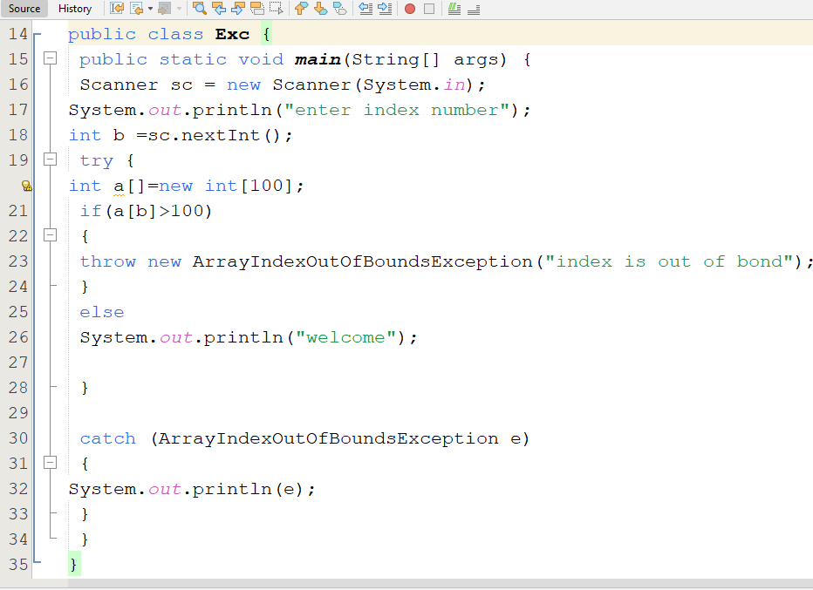

**Output:**

